
Holy Cross College

Semester 1 Examination 2013

Multiple Choice Booklet

Year 10 Science
Please place your student identification label in this box
(Extension)

Physics

Student Name
Student’s Teacher

Time allowed for this paper

Reading time before commencing work: 10 minutes
Working time for paper: 100 minutes

Materials required/recommended for this paper

To be provided by the supervisor

This Question/Answer Booklet
Data Sheet

To be provided by the candidate

Standard items: pens, pencils, eraser, correction fluid, ruler, highlighters.
Special items: non-programmable calculators satisfying the conditions set by the School Curriculum and Standards Authority for this course.

Important note to candidates

No other items may be taken into the examination room. It is your responsibility to ensure that you do not have any unauthorised notes or other items of a non-personal nature in the examination room. If you have any unauthorised material with you, hand it to the supervisor before reading any further.
SECTION 1 MULTIPLE CHOICE (50 marks)

Make a choice of answer and mark it with a cross on the answer sheet in the answer booklet.

1. Speed is:

(a) a measure of the rate of change of distance.
(b) a measure of the rate of change of displacement.
(c) is the same as velocity.
(d) a measure of how fast a vehicle moves.

2. To convert from kmh⁻¹ to ms⁻¹ you must:

(a) multiply by 1000 and then divide by 3600.
(b) multiply by 1000 and then divide by 360.
(c) multiply by 100 and then divide by 36 000.
(d) multiply by 10 and then divide by 360.

3. A ticker tape timer produced the section of ticker tape below.

The time interval between any two dots is 0.20 of a second. According to this section of ticker tape the moving object that produced this section of tape was travelling at:

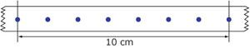

(a) 6.9 cms⁻¹.
(b) about 7.1 cms⁻¹.
(c) 7.5 cms⁻¹.
(d) 7.9 cms⁻¹.

4. In order for a force to cause a change in motion, the force has to be:

(a) unbalanced only.
(b) external only.
(c) balanced.
(d) external and unbalanced.

5. Newton's First Law states that:

(a) a body will accelerate in the direction of the unbalanced force acting on it.
(b) for every action there is an equal and opposite reaction.
(c) energy is conserved in all motion.
(d) a body will maintain its state of rest or uniform motion in a straight line unless acted on by an
external, unbalanced force.

6. In the diagram below the arrows show the size and direction of two force arrows acting on the bike.

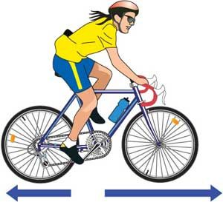

Which of the following describes the effect of the pair of forces on the bike?

(a) The bike will accelerate forward.
(b) The bike will remain stationary.
(c) The bike will decelerate.
(d) The bike will change its direction of motion.

7. Tom has a mass of 70.0 kg. His weight is therefore:

(a) 686 kg.
(b) 686 N.
(c) 786 N.
(d) 586 N.

8. What is the size of the force acting on a shopping trolley of mass 30.0 kg if the force produces an
acceleration of 2.00 ms⁻²?

(a) 60.0 N
(b) 20.0 N
(c) 0.13 N
(d) 15.0 N

9. A book at rest on the top of the horizontal surface of a table remains at rest because:

(a) the book has a weight force acting downwards.
(b) there is friction between the book and the table.
(c) there is no force acting between the table and the book.
(d) the downward force that the Earth exerts on the book exactly matches the force that the table
exerts upwards on the book.

10. Questions 10 - 13 relate to the diagram below.

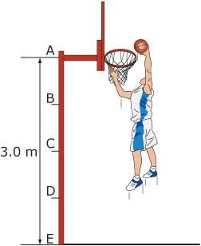

The basketball would have its greatest potential energy at position:

(a) E.
(b) A.
(c) B.
(d) D.

11. If the basketball player drops the ball into the hoop, the basketball in Question 10 would have its
greatest kinetic energy at position:

(a) B.
(b) A.
(c) E.
(d) C.

12. If the basketball player drops the ball into the hoop, the basketball in Question 10 would have equal
amounts of kinetic and potential energy closest to position:

(a) C.
(b) A.
(c) B.
(d) D.

13. If the basketball in Question 10 has a mass of 1.0 kg then its maximum kinetic energy would be
approximately:

(a) 3000 J.
(b) 0.3 J.
(c) 30 J.
(d) 300 J.

14.
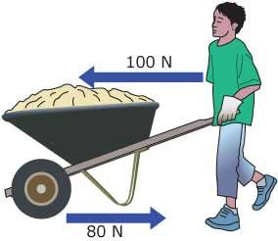

In the diagram above, the boy is pushing a wheelbarrow with a forward force of 100 newtons.
Friction acting in the opposite direction of the wheelbarrow has a value of 80 newtons. The
wheelbarrow is pushed a total distance of 10 metres. How much work did the boy do on the
wheelbarrow?

(a) 200 J
(b) 10 J
(c) No work is done on the wheelbarrow.
(d) 1000 J

15. When an object falls under gravity:

(a) its potential energy is converted to kinetic energy and heat energy.
(b) its kinetic energy is converted to potential energy and heat energy.
(c) its potential energy is converted to heat energy only.
(d) its kinetic energy is converted to heat energy only.

16. The concept of energy is most closely related to which of the following?

(a) The effect of a force.
(b) The work done by a force.
(c) The momentum of the object.
(d) The change in momentum of the object.

17. A moving car’s engine is turned off and it slows down as a result of friction and air drag. Which one
of the following statements is NOT TRUE?

(a) The car’s kinetic energy decreases.
(b) Heat is generated.
(c) The energy of the entire car/road/air system is constant.
(d) The car’s potential energy decreases.

18. A 25.0 kg child on a swing is 1.00 m above the ground at the lowest point of its path of travel and
3.00 m above the ground at the highest point. The speed of the child at the lowest point is:

(a) 7.67 ms⁻¹.
(b) 4.43 ms⁻¹.
(c) 6.26 ms⁻¹.
(d) 3.13 ms⁻¹.

19. A rock is pushed off the edge of a cliff and falls for 3.00 s before striking the ground? Which of the
following factors would NOT affect its final velocity?

(a) Gravity.
(b) Mass of the rock.
(c) Direction and strength of wind.
(d) Shape of the rock.
20.
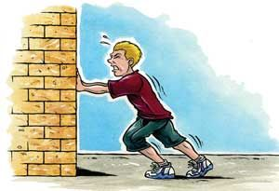

In the diagram shown above:

(a) no work is done on the wall because the wall is not moving in the direction of the force.
(b) the work done on the wall increases the kinetic energy of the wall.
(c) the energy used by the boy is doing work on the wall.

21. Calculate the velocity of a bus that travels between two traffic lights 145 metres apart in 20.0 seconds.

(a) 7.00 ms⁻¹
(b) 7.25 ms⁻¹
(c) 6.25 ms⁻¹
(d) 7.50 ms⁻¹

22. Acceleration is defined as:

(a) the rate of change of speed.
(b) the rate of change of displacement.
(c) the rate of change of distance.
(d) the rate of change of velocity.

23. A decreasing rate of change of velocity could be called:

(a) positive acceleration.
(b) negative velocity.
(c) deceleration.
(d) braking.

24. In the absence of air resistance:

(a) heavier objects would accelerate toward the ground faster than lighter ones.
(b) more streamlined objects would accelerate toward the ground faster than less streamlined ones.
(c) all objects regardless of mass would accelerate toward the ground with the same velocity.
(d) objects with more mass would accelerate toward the ground faster than objects with less mass.

25. What is the acceleration of a car if it increases its velocity from 5.00 ms⁻¹ to 15.0 ms⁻¹ in 4.00 s?

(a) 2.50 ms⁻²
(b) 2.50 ms⁻¹
(c) 150 ms⁻²
(d) 5.20 ms⁻²
26. The graph below shows displacement–time data for a vehicle travelling at a constant velocity.

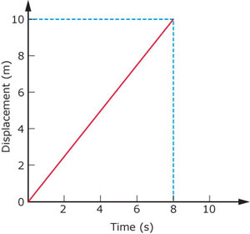

The velocity of the vehicle is:

(a) 2.25 ms⁻¹
(b) 0.25 ms⁻¹
(c) 1.55 ms⁻¹
(d) 1.25 ms⁻¹

Questions 27-29 refer to the following graphs.

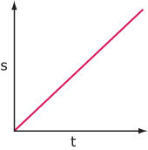
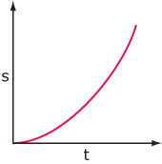
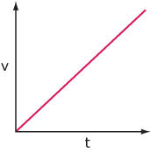
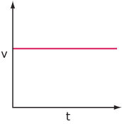

A B C D

27. The graphs that could represent a vehicle accelerating at a constant, non-zero rate are:

(a) C only.
(b) B and D.
(c) A and B.
(d) C and D.

28. The graphs above that show a vehicle with constant velocity are:

(a) B and C.
(b) A and C.
(c) A and B.
(d) C and D.

29. Which graphs above might represent the motion of a freely-falling body near the surface of the
Earth?

(a) A and C.
(b) C and D.
(c) B and D.
(d) A and D.

30. The sample of ticker tape below shows:

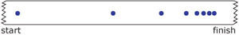

(a) a uniformly decelerating vehicle.
(b) a stationary vehicle.
(c) a uniformly accelerating vehicle.
(d) a vehicle travelling at a constant velocity.

31. The change in position of an object and its direction is known as:

(a) displacement.
(b) distance.
(c) average speed.
(d) average velocity.

32. How long would a car travelling at a speed of 60 kmh⁻¹ take to cover a distance of 90 km?

(a) 1½ hours
(b) 2 ½ hours
(c) 3 ½ hours
(d) 4 ½ hours

33. Which line on the following graph represents a deceleration?

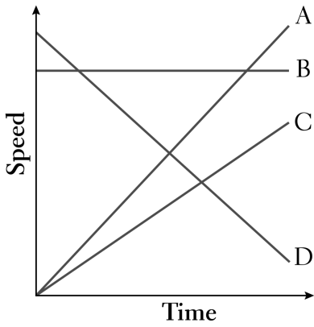
(a) A
(b) B
(c) C
(d) D

34. An object starts from rest and accelerates at 5.0 ms⁻². After 4.0 seconds, its speed will be:

(a) 0 ms⁻¹.
(b) 10 ms⁻¹.
(c) 20 ms⁻¹.
(d) 30 ms⁻¹.

35. The tendency of an object to resist changes in its motion is called:

(a) inertia.
(b) weight.
(c) friction.
(d) work.

36. Newton’s Law, known as the Law of Inertia, is:

(a) his first law.
(b) his second law.
(c) his third law.
(d) none of the above.

37. "If an object has zero acceleration, the object must be at rest". This statement is:

(a) always correct.
(b) sometimes correct.
(c) never correct.

38. An object is acted upon by a push force of 50 N and a total frictional force of 40 N. The nett force will
be:

(a) 10 N backwards.
(b) 10 N forwards.
(c) 90 N backwards.
(d) 90 N forwards.

39. The size of the acceleration acting on an object of mass 10.0 kg that has a nett force of 3.0 N acting on
it will be:

(a) 13.0 ms⁻².
(b) 3.3 ms⁻².
(c) 0.3 ms⁻².
(d) 30.0 ms⁻².

40. A cyclist has a weight of 500 N, the road pushes up with 500 N, the push force forwards is 30 N and
the friction opposing the motion is 32 N. The cyclist will be:

(a) stationary.
(b) accelerating.
(c) decelerating.
(d) travelling at constant velocity.

41. When you hit a tennis ball with a tennis racquet, the action force is the force of the racquet hitting the
ball and the reaction force is:

(a) the ball hitting the racquet.
(b) the jarring force you feel through your hand.
(c) the weight force on the ball.
(d) the weight force on you.

The next two questions refer to the following graph.

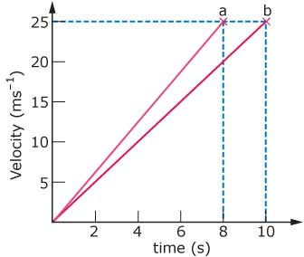

42. The acceleration of the vehicle producing line (a) on the graph is:

(a) 5.00 ms⁻².
(b) 3.12 ms⁻².
(c) 6.25 ms⁻².
(d) 7.25 ms⁻².

43. According to the graph above:

(a) both line (a) and line (b) represent the same acceleration.
(b) line (b) represents a higher acceleration than line (a).
(c) you cannot tell acceleration from this graph.
(d) line (a) represents a higher acceleration than line (b).

44. Find the final velocity of a cyclist travelling at 3.00 ms⁻¹ if she accelerates at 1.20 ms⁻² for
5.00 seconds.

(a) 9.00 ms⁻¹
(b) 19.0 ms⁻¹
(c) 99.0 ms⁻¹
(d) 0.900 ms⁻¹

45. An object has a mass of 250 kg . It would have a weight of closest to:

(a) 2.5 N.
(b) 25 N.
(c) 250 N.
(d) 2500 N.

46. A driver noticed that his speedo reading was 118.8 kmh⁻¹. Which of the following represents the
speedo reading in ms⁻¹?

(a) 11880 ms⁻¹
(b) 33 ms⁻¹
(c) 118 ms⁻¹
(d) 330 ms⁻¹

47. Which one of these is a vector quantity?

(a) area
(b) speed
(c) energy
(d) force

The following diagrams represent the marks made on four separate tapes by the timing device as
the cart moves.
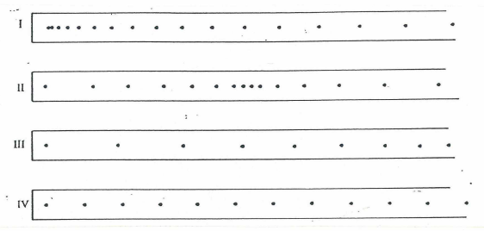
48. Which one of the diagrams best indicates that the cart was slowing down throughout the recorded time
interval?

(a) I (b) II (c) III (d) IV

49. Which one of the diagrams best indicates that the cart started from rest and accelerated?

(a) I (b) II (c) III (d) IV

50. Which one of the diagrams best indicates that the cart was travelling at constant speed?

(a) I (b) II (c) III (d) IV

END OF SECTION 1

